Project Design Document

Version 1 (In progress)

by

Lakshmi Naidu

Document History
Date | Details | Version | Remarks
06/17/14 | Document Created | v1

Index

1.Introduction......................................................................................................................................1
2.Overview..........................................................................................................................................1
3.Design in detail................................................................................................................................2
4.Flowchart.........................................................................................................................................3
5.References.......................................................................................................................................4

    - Introduction

The main purpose of this document is to get a clear understanding of the implementaion of the Causal Message Ordering among several process. This protocol is realized using the 'Skeen's algorithm. The communication amidst the processes will be done using socket programming. The language used to program this implementaion will be Java.

    - Overview

The main goal of Causal Message Ordering is to ensure that order of the messages are maintained. According to Skeen's algorithm, when a message is sent to other process, it waits for all the receiving processes to send back their respective timestamps when the message was delivered and the highest timestamp is recorded by sending process and finally the message is delivered with the highest timestamp to all other processes (destination set).

Every other process would also have a buffer which can hold the messages it has received. They are ordered according to the order in which it was sent in this way we can maintain the causal order for the messages .

Once these messages are sent and received by the respective process, it would be recorded in the logfile along with the timestamps of when it was sent and received. Later a helper program will help us understand if the messages have been read in the same order as they were sent. There will be a copy of the order of the messages that are sent, so that they are verified by the helper program.

The timestamps mentioned above would be according to Lamport's logical clock.

1

    - Design in detail

Since this is a project related to distributed systems we will setup an environment where there are several processes that communicate with one another (using socket programming). For this purpose we are using the servers (net01- net45). Initailly there will be a setup for deciding the sending process and its destination sets.

Once done with the initial set up, the next step is to start the communication:

- m_send : sends the message to the destination set
- m_receive: receives messages from other processes

The next module is to ensure the Total Ordered Multicast, which idealy maintains the order of message delivery just as they were initially sent. This would include using Skeen's algorithm and timestamps according to Lamport's logical clock.

The receiving process would have a queue that would collect all its messages and deliver them only when it has the smallest timestamp.

- m_deliver : deliver's the messages in order explained in skeen's algorithm

Once the message is sent or received there will be an entry in the shared log file along with its timestamp.

The results of the implementation will be verified by an automated helper program which will verify the property of the Total Order Multicast independently.

2

    - Flowchart

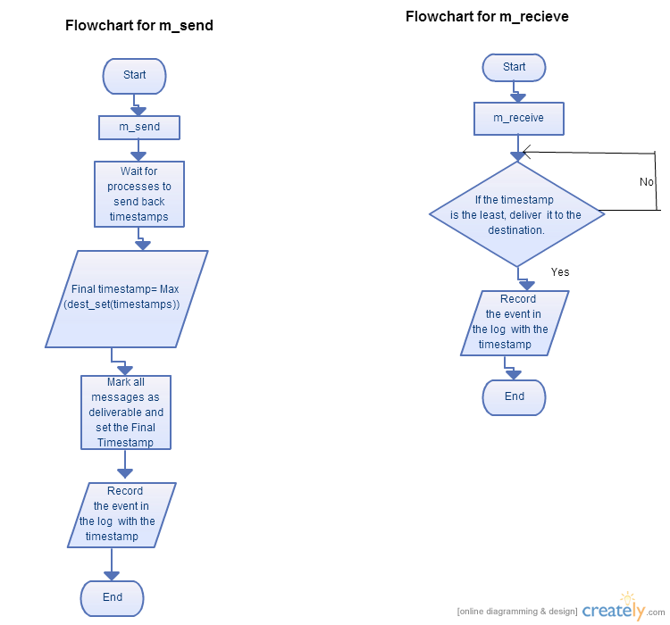

3

    - References
i) http://blog.slickedit.com/2007/05/how-to-write-an-effective-design-document/

4

